Project B: A Rocket With Satellites
By: Dhruv Koul
NetID: dko269

Goals:

The project is a depiction of a rocket that has its own satellites orbiting around it. The goal of the project was to shift into making 3D objects without using glVertex deprecated commands – instead we were to use vertex arrays in order to create these 3D objects, defining vertices, colors, etc. We were to get used to vertex arrays, camera projections, including the Perspective and Ortho views, as well as multiple viewports.

User's Guide:

When one starts the program, they see 4 viewports, three of which are fixed (top left, bottom left and right), and the last one (top right) is one that isn't fixed, but can be rotated using the mouse to explore all angles. Everything is stationary except for 4 little “satellites” that are moving around the screen, around the “rocket”.

The user is prompted to press the 'H' key in order to get the manual of instructions to appear on screen. They can interact with the top right viewport by clicking, holding and dragging around to see the view as they like. There is a grid in each of the viewports so the user can see how the objects have rotated.

One nice thing is that if the user maximizes the graphics screen or from a maximized size decides to bring it down to the normal size, the images don't distort in odd manners in response to the changing of the display window's size. They stay the same on the screen and don't get weirdly stretched out or squeezed in due to a change in graphics screen size.

The user can press the 'Z' key to change between the Perspective and the Ortho views while not changing the orientation of the current view that the camera is on. They can use the 'R' key to get the top right viewport back into the default view as occurs when the user first runs the program. They can also use the 'Left' and 'Right' arrow keys to have the other “satellites” orbit the stationary yet spinning “rocket”, and the user can press either 'Enter', 'Space bar' or 'Q' to quit the program.

Code Guide:

I used quite a bit of the starter code that Professor Tumblin provided in his starter code projects posted on Blackboard. The myDisplay function within the program is set up in the following manner: set up viewport, set up camera view, draw the scenery. I am doing all of the drawing in a function called drawScene, that itself contains different function calls to set up the scenery. I got help from classmates on how to create shapes using vertex arrays and ideas on how to switch between Perspective and Ortho views, and proceeded to make the scenery move and rotate just like was occurring in Project A. All of the sources used will be presented in a “Sources” section at the end of this report.

Per a friend's suggestion, I included classes in the .h file that are used to draw the Pyramid and Prism shapes; each class contains an array for vertices, indices and colors that are set and drawn within the .cpp file. I also changed the doCamChoice function to take a parameter, camChoice, which made it easier to switch between Perspective and Ortho views, as per suggestion of another classmate. I am also declaring all of the member functions of the different shape classes within the .cpp file, where all of the drawing is happening, and I learned how to draw using help from a website, which will be included in the “Sources” section at the end.

I am using PushMatrix and PopMatrix to save and return my matrix stacks as I am drawing objects, and am using similar methodology that I used in Project A to make shapes move and rotate, including using glRotated and glTranslated.

I apologize for the untidiness of the code again. I didn't realize this project would be as tough as it was and lost track of commenting as I went through. I have highlighted in the code where I have utilized classmates or websites help, so that should be documented. I am also including the sources in this report at the end.

Results:

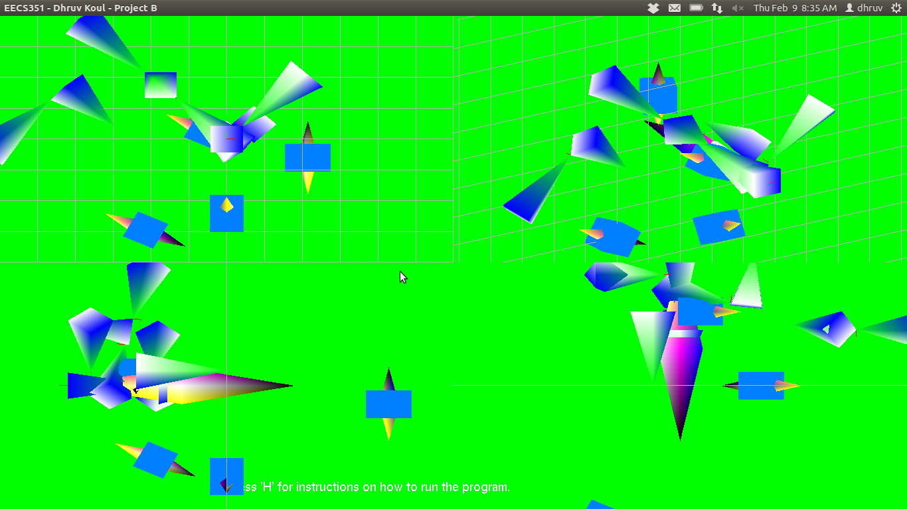
Figure 1 – Normal 4-viewport view of the screen.

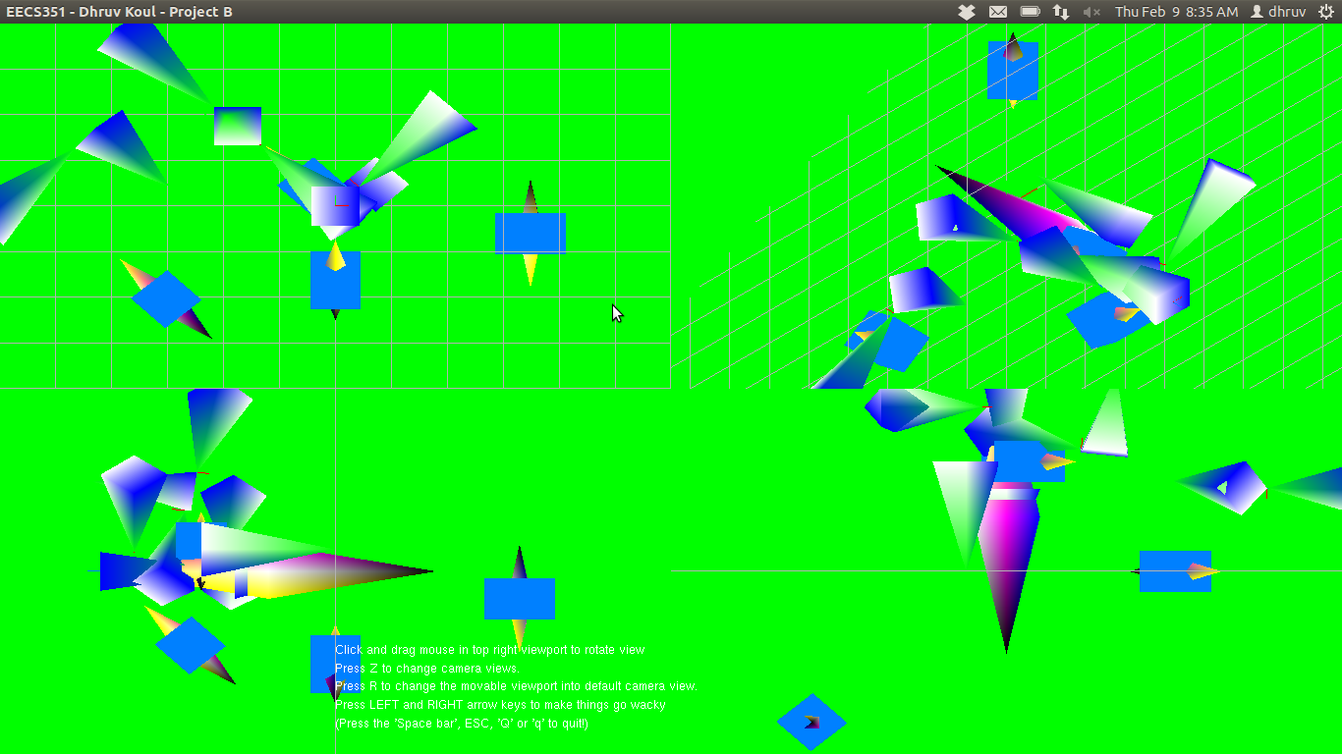
Figure 2 – Help menu on screen after user presses 'H' and top-right viewport has been adjusted using the mouse.

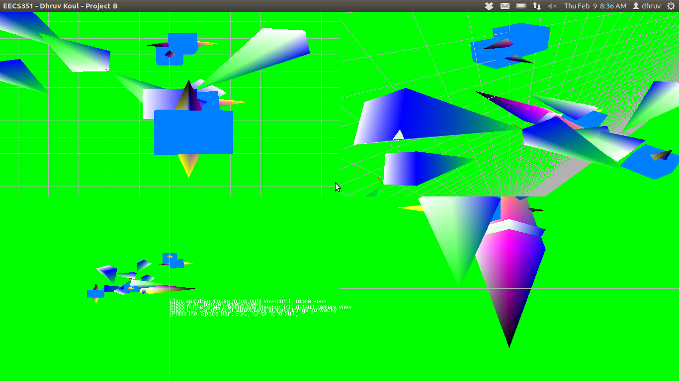
Figure 3 – Switched between Perspective and Ortho view: you can note the difference from other pictures.

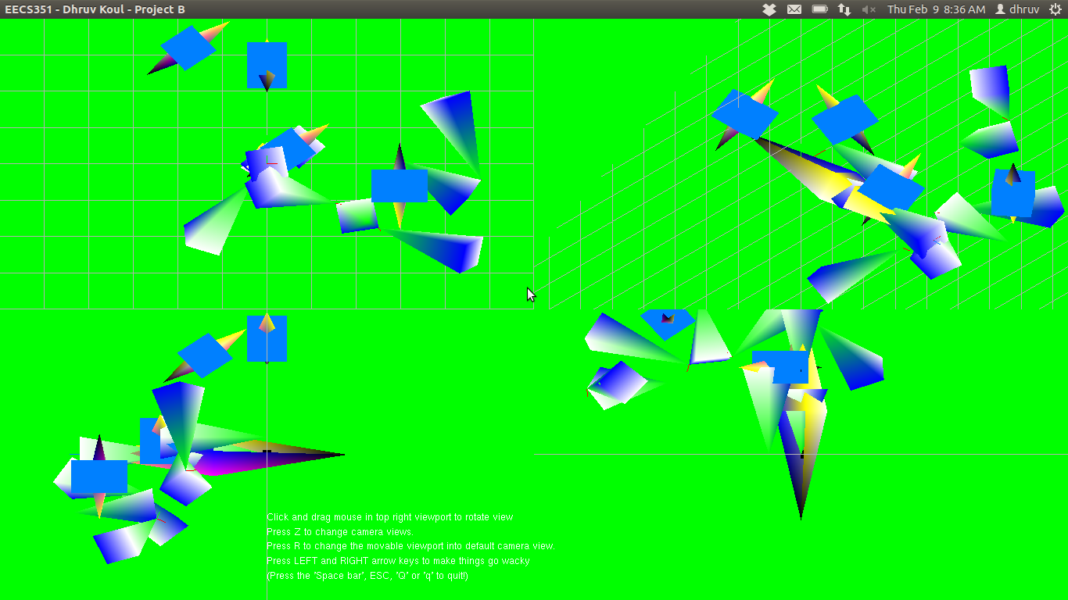
Figure 4 – Rotating one side of the screen – notice how it compares with Figure 5 which is next...

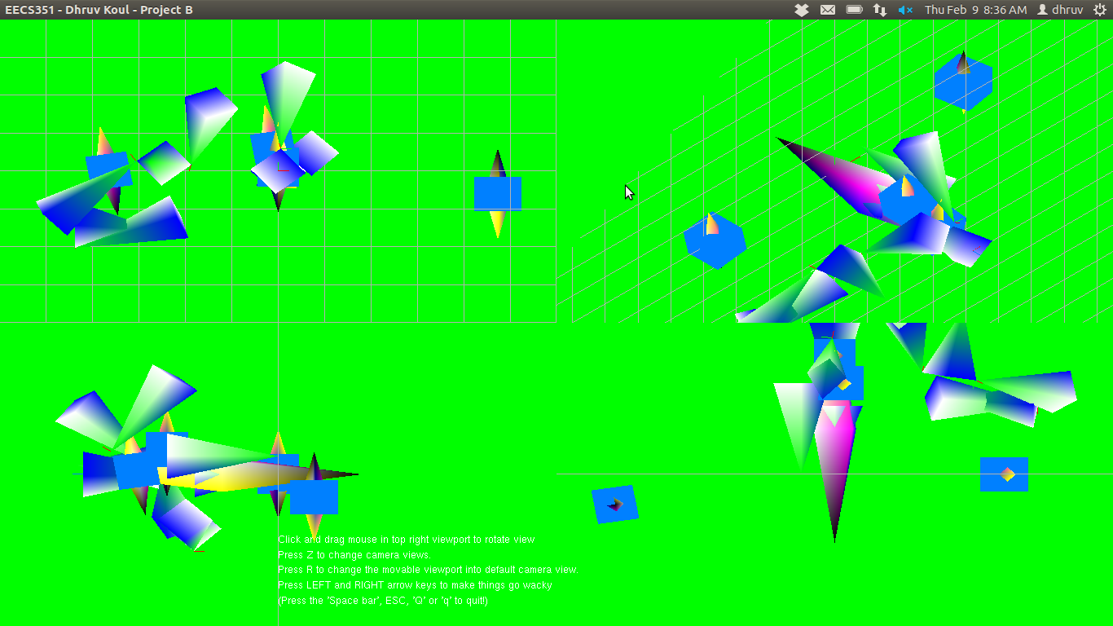
Figure 5 – Objects have moved along the screen so the user can notice the difference.

Sources:

- I adapted a lot of code from Professor Tumblin. I modified code and built off what had already been provided so it was helpful for me to learn how some of the methods worked.

- I got help on how to attack the vertex arrays from my classmate, Khalid Aziz, and he helped me understand how to build vertex arrays for shapes such as pyramids and tetrahedrons. He was very helpful to me in understanding vertex arrays.

- I used this website: http://www.songho.ca/opengl/gl_vertexarray.html to help me draw the shapes once I had the vertex arrays formulated. I also got help from Khalid in drawing the shapes as well.

- I got the idea of how to adjust from Perspective view to Ortho view and back from my classmate, Cassandra Rommel. She gave me the idea to pass the int camChoice parameter to the doCamChoice function so it would be easier to toggle between the views.

